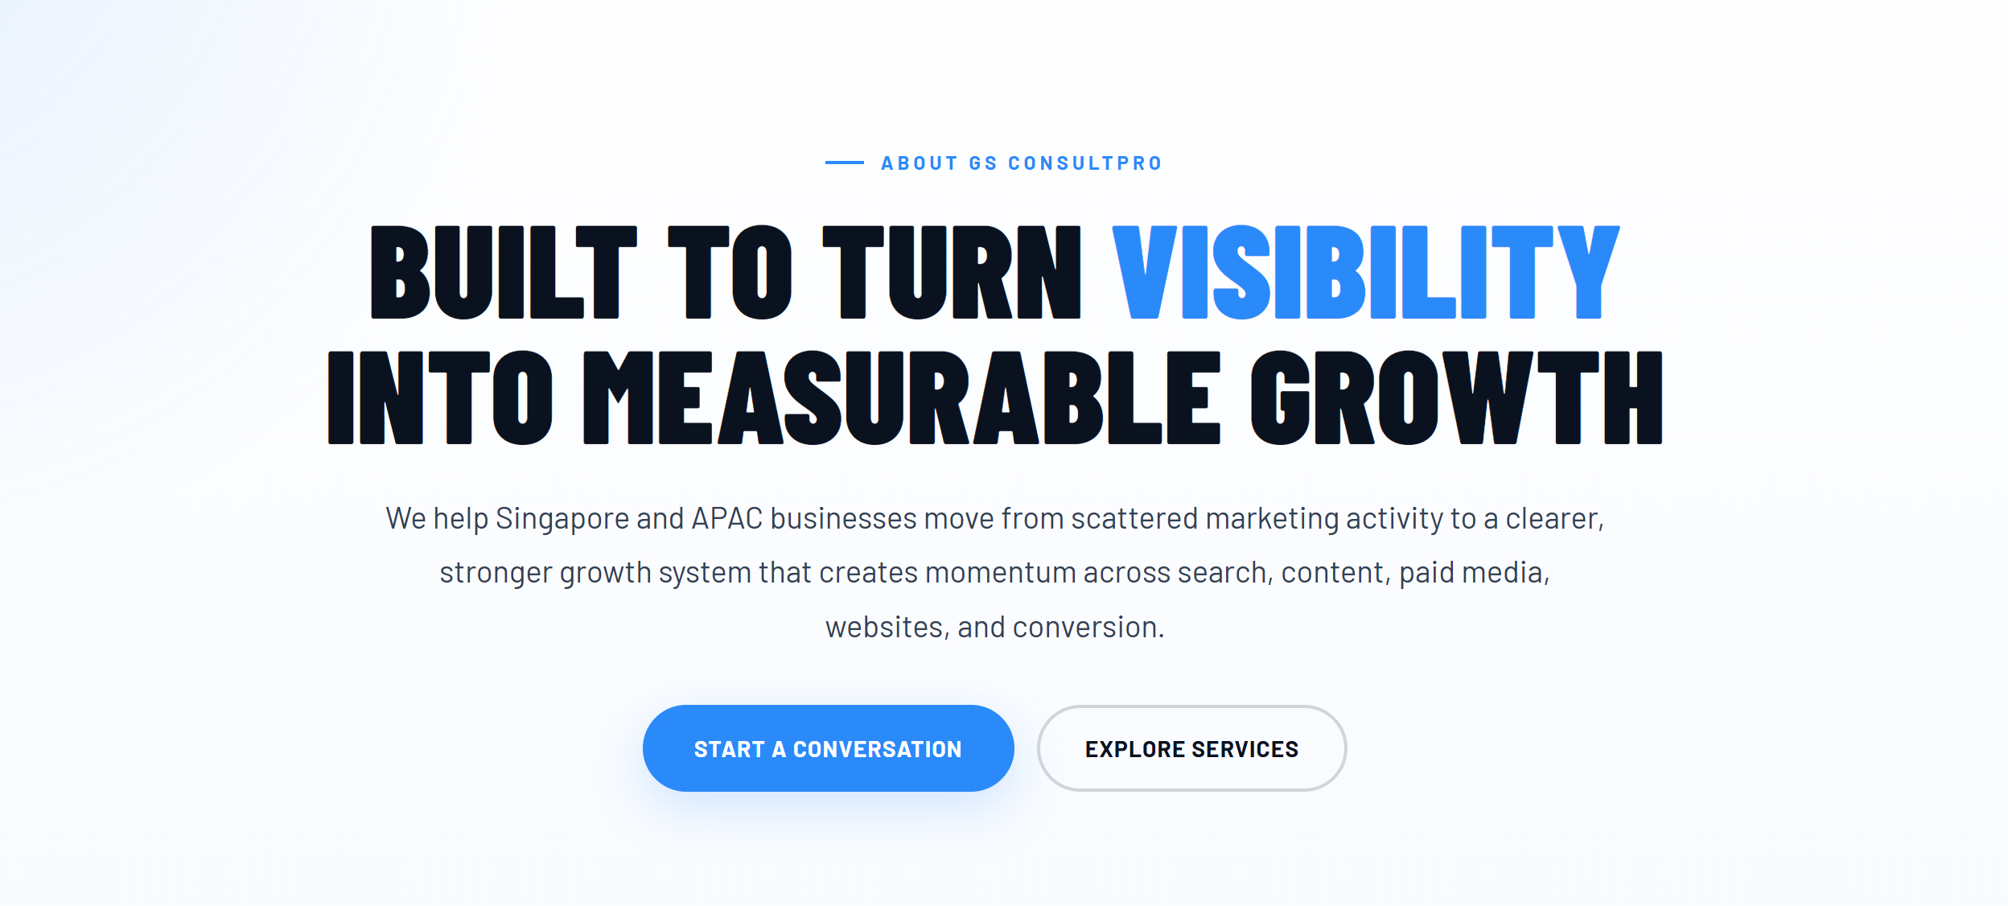
We help Singapore and APAC businesses move from fragmented marketing activity to structured growth systems designed to strengthen visibility, generate demand, and support measurable business growth.

Remove ‘Start a Conversation’ button from here.

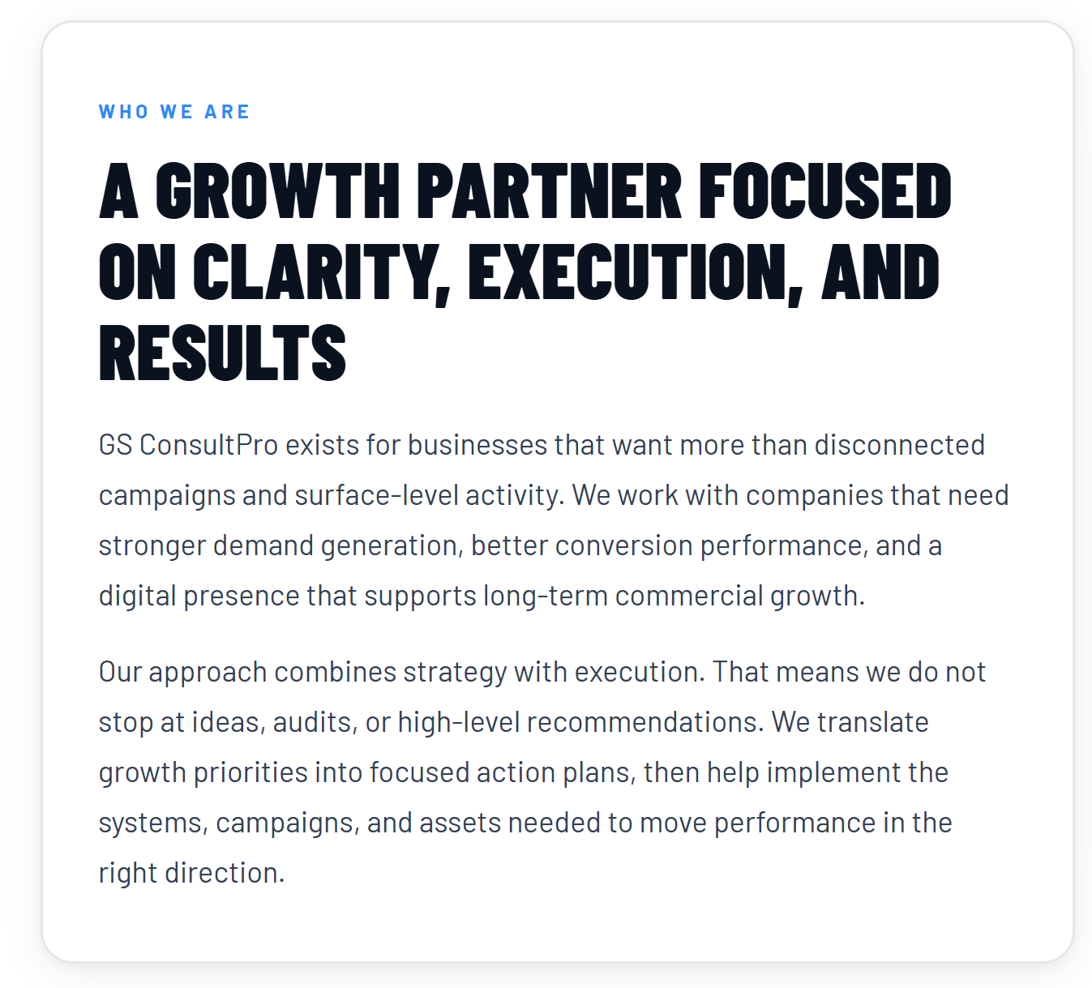
I like the heading but it seems long. May be change it to
A GROWTH PARTNER BUILT FOR EXECUTION AND RESULTS

Minor changes just to tighten.

…. We work with companies that need stronger demand generation, better conversion performance, and scalable digital growth.
Our approach combines strategy with execution. We translate growth priorities into focused action plans and help implement the systems, campaigns, and digital assets needed to support measurable business outcomes.

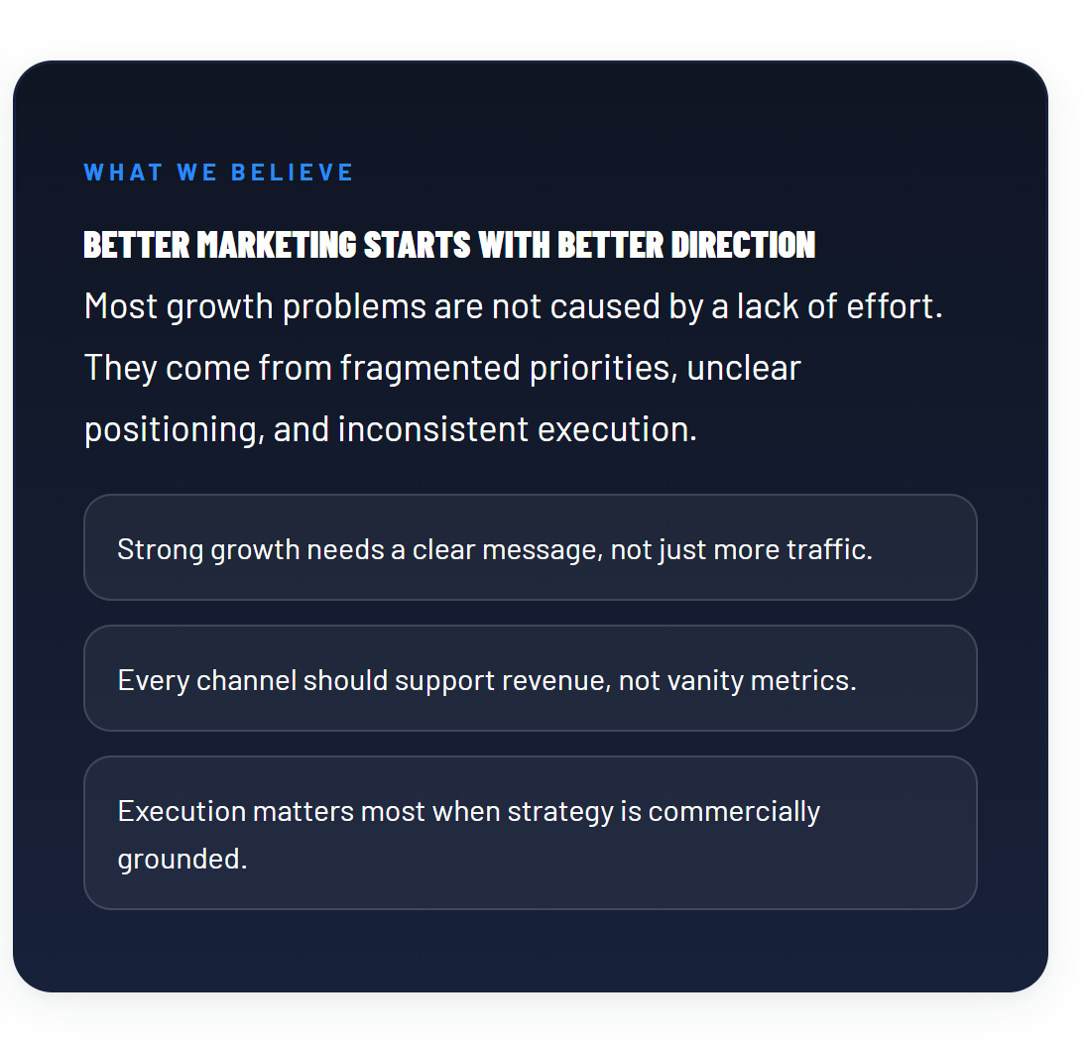
We are doing more than marketing so the title needs to change to BETTER GROWTH STARTS WITH BETTER DIRECTION

Execution matters most when strategy is grounded.

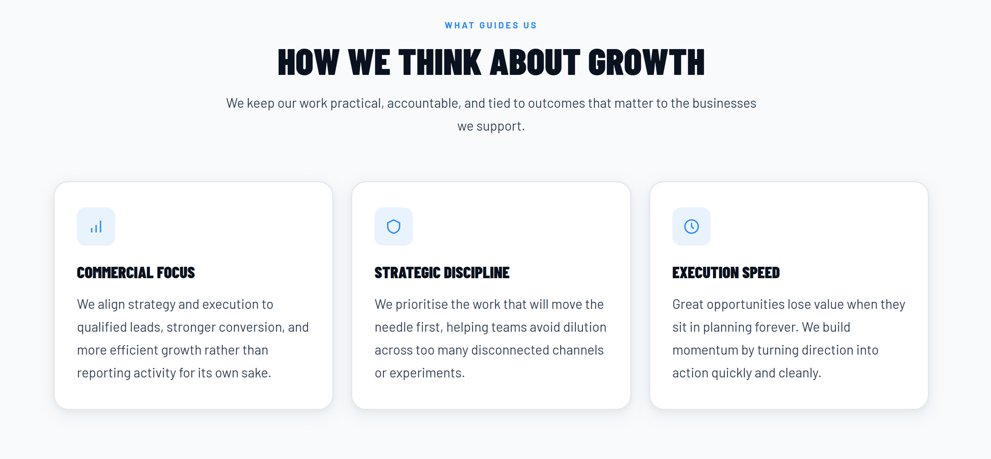
We keep our work focused, accountable, and aligned with measurable business outcomes

Commercial Focus
We align strategy and execution around qualified demand, stronger conversion, and measurable business growth rather than activity for its own sake.

STRATEGIC DISCIPLINE
This one is strong already.
Only tiny refinement: replace experiments with “initiatives”

EXECUTION SPEED
Great opportunities lose value when they stay in planning too long. We turn direction into focused action quickly and cleanly.

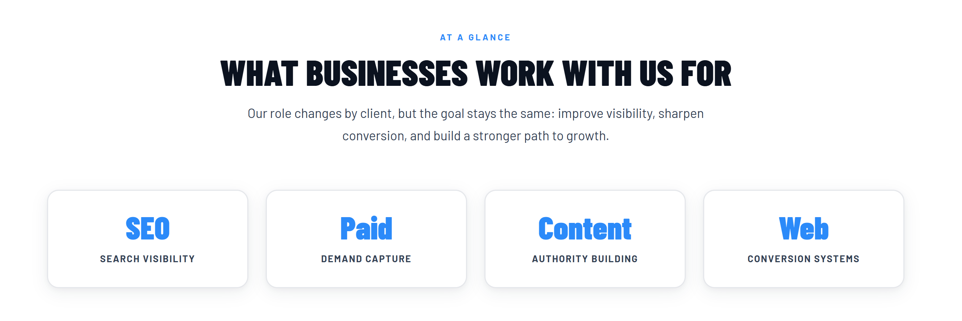

WHAT WE HELP BUSINESSES ACHIEVE
Our role changes by client, but the goal remains the same: strengthen visibility, improve conversion, and support measurable business growth.

These 4 cards focus on marketing and our focus is broader
SEO
Search Authority
Content
Authority Building
Outreach
Demand Acceleration
Web
Experience Optimisation
Automation
Workflow Intelligence
Partnerships
Ecosystem Growth
Events
Executive Engagement
Enablement
Capability Development


HOW WE WORK WITH CLIENTS
We bring structure to growth initiatives so businesses can move faster with clearer direction and stronger alignment.
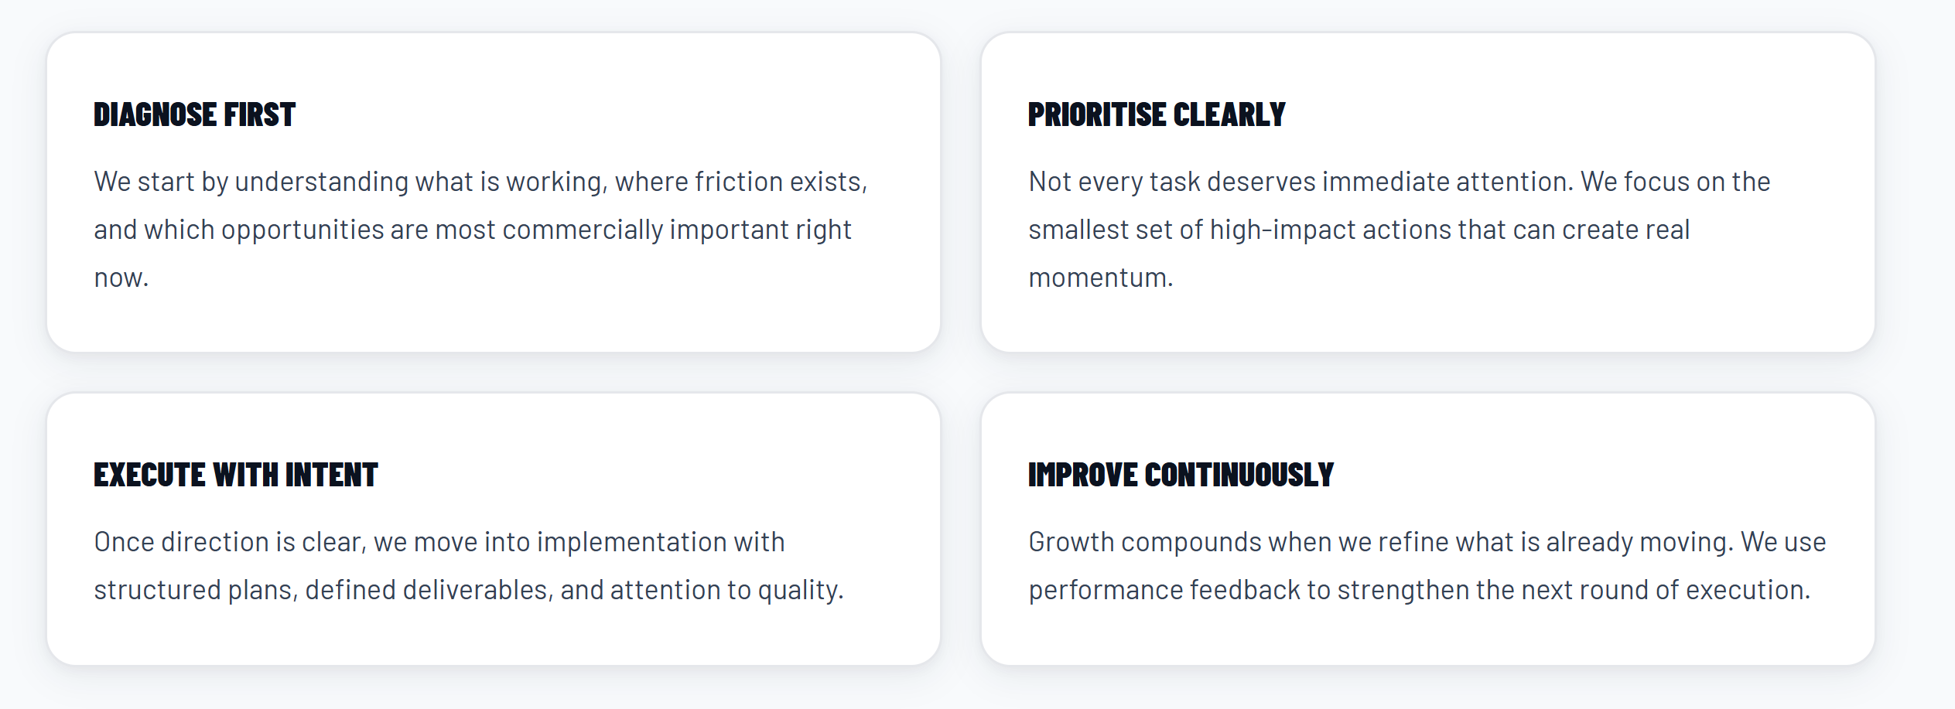
Quite strong. Minor changes
DIAGNOSE FIRST
We start by understanding what is working, where friction exists, and which opportunities matter most commercially.
PRIORITISE CLEARLY
Not every task deserves immediate attention. We focus on the highest-impact actions that create real momentum.
EXECUTE WITH INTENT
Once direction is clear, we move into execution with structured plans, defined deliverables, and attention to quality.
IMPROVE CONTINUOUSLY
Growth compounds when execution is continuously refined through performance feedback and iteration.

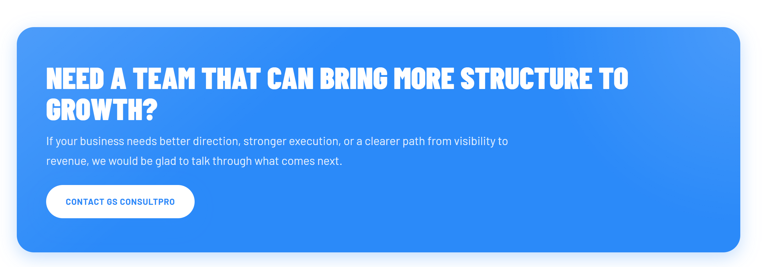
NEED A TEAM THAT CAN BRING MORE STRUCTURE TO GROWTH INITIATIVES?

